CRM на MRP

- Хранимые процедуры
create procedure companie @com char(20) as
select count(*) from orders
where company = @com

create procedure weeks @a int, @b int as
select company, q_light,q_dark,q_smooth from orders
where week between @a and @b

- Скриншот
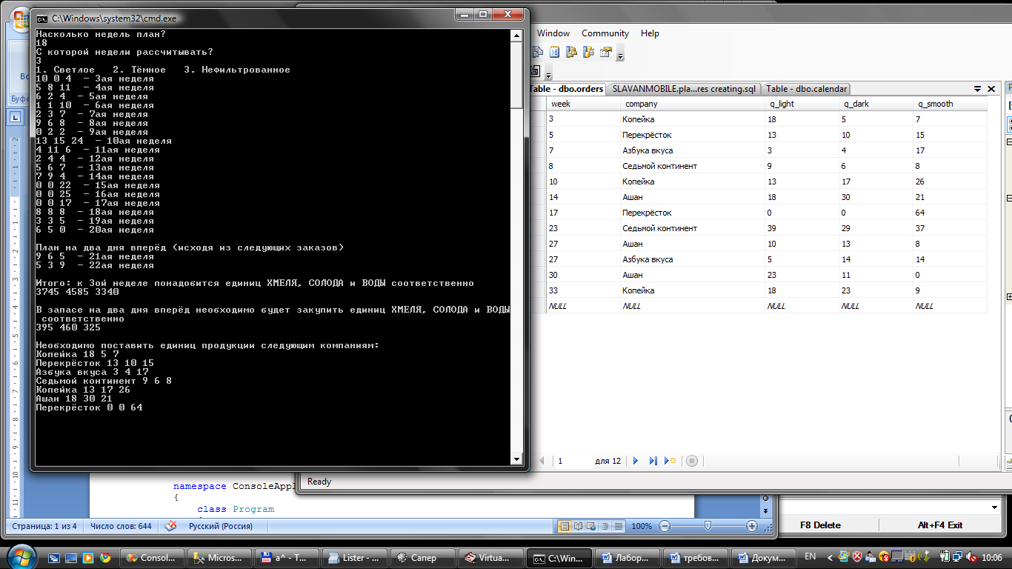

- Код программы
using System;
using System.Collections.Generic;
using System.Linq;
using System.Text;
using System.Data.SqlClient;

namespace ConsoleApplication2
{
class Program
{
static void Main(string[] args)
{
string auth_str;
int cmel = 0; int voda = 0;
int solod = 0;
SqlConnectionStringBuilder builder = new SqlConnectionStringBuilder();
//builder["Provider"] = "provider=SQLOLEDB.1";
builder["Server"] = "(local)";
builder["Integrated Security"] = "true";
//builder["User Instance"] = "false";
builder["Database"] = "planing";
//builder["uid"] = "a";
//builder["password"] = "";
//builder["Pooling"] = "False";
auth_str = builder.ConnectionString;
//Console.WriteLine(builder.ConnectionString);

WithMSSQL con1 = new WithMSSQL();

string query = "select cmel, solod, voda from beer";
string [,] matrix = new string[3,3];
matrix = con1.commandSQL(query, con1.connectToSQL(auth_str));

Console.WriteLine("Насколько недель план?");
int days = int.Parse(Console.ReadLine());
Console.WriteLine("С которой недели рассчитывать?");
int week = int.Parse(Console.ReadLine());

query = "select light, dark, smooth from calendar where week between " + week + " and " + (week + days + 2);
/*string[,] help = new string[days, 3];
help = con1.commandSQL(query, con1.connectToSQL(auth_str));
int [,] matrix2 = new int[days, 3];
matrix2 = System.Convert.ToInt32(help);*/

string[,] matrix2 = new string[days, 3];
matrix2 = con1.commandSQL(query, con1.connectToSQL(auth_str));

Console.WriteLine("1. Светлое 2. Тёмное 3. Нефильтрованное");

for (int i = 0; i < days + 2; i++)
{
for (int j = 0; j < 3; j++)
Console.Write(matrix2[i,j] + " ");
Console.WriteLine(" - " + (week + i) + "ая неделя");
if (i == days - 1)
{
Console.WriteLine();
Console.WriteLine("План на два дня вперёд (исходя из следующих заказов)");
}
}

Console.WriteLine();

for (int i = 0; i < days; i++)
{
cmel += Convert.ToInt32(matrix[0, 0]) * Convert.ToInt32(matrix2[i, 0]) + Convert.ToInt32(matrix[1, 0]) * Convert.ToInt32(matrix2[i, 1]) + Convert.ToInt32(matrix[2, 0]) * Convert.ToInt32(matrix2[i, 2]);
solod += Convert.ToInt32(matrix[0, 1]) * Convert.ToInt32(matrix2[i, 0]) + Convert.ToInt32(matrix[1, 1]) * Convert.ToInt32(matrix2[i, 1]) + Convert.ToInt32(matrix[2, 1]) * Convert.ToInt32(matrix2[i, 2]); ;
voda += Convert.ToInt32(matrix[0, 2]) * Convert.ToInt32(matrix2[i, 0]) + Convert.ToInt32(matrix[1, 2]) * Convert.ToInt32(matrix2[i, 1]) + Convert.ToInt32(matrix[2, 2]) * Convert.ToInt32(matrix2[i, 2]); ; ;
}
Console.WriteLine("Итого: к " + week + "ой неделе понадобится единиц ХМЕЛЯ, СОЛОДА и ВОДЫ соответственно");
Console.WriteLine(cmel + " " + solod + " " + voda);

cmel = 0;
solod = 0;
voda = 0;

for (int i = days; i < days + 2; i++)
{
cmel += Convert.ToInt32(matrix[0, 0]) * Convert.ToInt32(matrix2[i, 0]) + Convert.ToInt32(matrix[1, 0]) * Convert.ToInt32(matrix2[i, 1]) + Convert.ToInt32(matrix[2, 0]) * Convert.ToInt32(matrix2[i, 2]);
solod += Convert.ToInt32(matrix[0, 1]) * Convert.ToInt32(matrix2[i, 0]) + Convert.ToInt32(matrix[1, 1]) * Convert.ToInt32(matrix2[i, 1]) + Convert.ToInt32(matrix[2, 1]) * Convert.ToInt32(matrix2[i, 2]); ;
voda += Convert.ToInt32(matrix[0, 2]) * Convert.ToInt32(matrix2[i, 0]) + Convert.ToInt32(matrix[1, 2]) * Convert.ToInt32(matrix2[i, 1]) + Convert.ToInt32(matrix[2, 2]) * Convert.ToInt32(matrix2[i, 2]); ;
}

Console.WriteLine();
Console.WriteLine("В запасе на два дня вперёд необходимо будет закупить единиц ХМЕЛЯ, СОЛОДА и ВОДЫ соответственно");
Console.WriteLine(cmel + " " + solod + " " + voda);

//На какой неделе и кому что требуется поставить

/*query = "select company, q_light,q_dark,q_smooth from orders where week between " + week + " and " + (week + days);*/
query = "exec weeks " + week + ", " + days;
string[,] matrix3 = new string[days, 4];
matrix3 = con1.commandSQL(query, con1.connectToSQL(auth_str));

Console.WriteLine();
Console.WriteLine("Необходимо поставить единиц продукции следующим компаниям:");

for (int i = 0; i < days; i++)
{
for (int j = 0; j < 4; j++)
Console.Write(matrix3[i, j] + " ");
Console.WriteLine();
}

}

public class WithMSSQL
{
public SqlConnection connectToSQL(string aut_str)
{
SqlConnection myConnection = new SqlConnection(aut_str);
myConnection.Open();
return myConnection;

}
public string[,] commandSQL(string command, SqlConnection myConnection)
{
string [,] comp = new string[32,32];
SqlCommand mycommand = new SqlCommand(command, myConnection);
SqlDataAdapter sq = new SqlDataAdapter(mycommand);

System.Data.DataSet ds = new System.Data.DataSet();
sq.Fill(ds);
for (int i = 0; i < ds.Tables[0].Rows.Count; i++)
{
for (int j = 0; j < ds.Tables[0].Columns.Count; j++)
{
//comp[i, j] = System.Convert.ToInt32(ds.Tables[0].Rows[i][j]);
comp[i, j] = Convert.ToString(ds.Tables[0].Rows[i][j]);
//Console.Write(ds.Tables[0].Rows[i][j] + " ");
}
}
return comp;

}
}
}
}

